B. Ed Academic Faculty

S. No | Name of the faculty members |  | Qualification |  | Designation | Photos
1 | Dr. A.R. Anandha Krishnaveni, |  | M.A, M.Ed,M.Phil. NET, Ph.D |  | Principal
2 | Mrs. S. Kasthuri |  | M.A., M.Ed |  | Assistant Professor in Tamil | 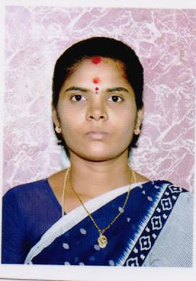
3 | Mr. G. Revanth |  | M.A., M.Ed., |  | Assistant Professor in English
4 | Mr. T. Rasukkutty |  | M.A., M.Ed |  | Assistant Professor in English
5 | Mr. A. Ramkumar |  | M.Sc., M.Ed., |  | Assistant Professor in Mathematics | 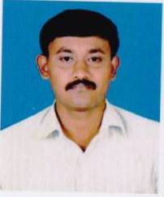
6 | Mrs. R. Madaselvi |  |  | M.Sc., M.Ed., M.Phil. | Assistant Professor in Physical Science
7 | Mr. B. Subbiah |  |  | M.Sc., M.Ed | Assistant Professor in Physical Science
8 | Mrs. S. Sivagamasundari |  |  | M.Sc., MA, M.Ed., M.Phil. | Assistant Professor in Bio Science
9 | Ms. M. Sugumari |  |  | M.A., M.Ed., M.Phil., | Assistant Professor in History
10 | Mr. V. Ramkumar |  |  | M.A., M.Ed., | Assistant Professor in History | 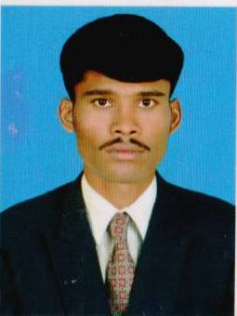
11 | Mrs. S. Rajalakshmi |  |  | M.A., M.Ed., M.Sc., | Assistant Professor in Psychology | 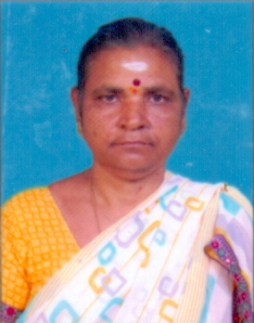
12 | Mrs. S. Sankareswari |  |  | M.Com., M.Ed., | Assistant Professor in Commerce | 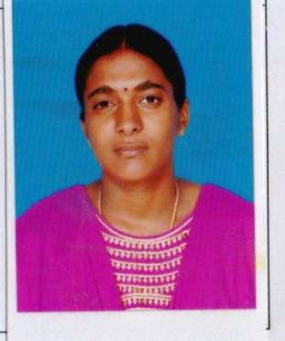
13 | Mr. R. Kannan |  |  | M.A., M.Ed., | Assistant Professor in Economics | 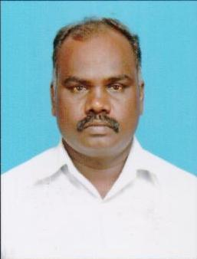
14 | Mr. M. Hari Baskar |  |  | M.Sc. | Assistant Professor in Fine Arts | 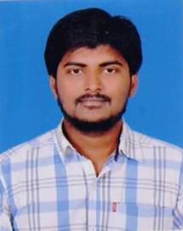
15 | Ms. R. Krishna Bharathi |  |  | M.A | Assistant Professor in Performing Arts | 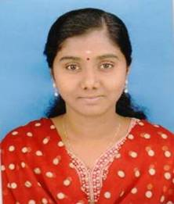
16 | Mr. R. Muthuram | M.PEd., MPhil |  |  | Physical Director | 